ONLINE DONATION PLATFORM
@CREATIVITY THINK (9483175986/7019689991)

ABSTRACT:
The Online Donation Platform is a web application designed to streamline charitable giving for users and organizations. Users can browse donation campaigns, register, make donations, and view impact reports through interactive dashboards. Administrators can add and manage campaigns, process donor payments, track analytics, and send updates to donors. The backend uses Django and Django Rest Framework to handle secure data storage, authentication, and business logic, while the frontend leverages React, Axios, and Chart.js for interactive dashboards and responsive user interfaces. The platform improves transparency, donor engagement, and reporting for charitable initiatives..

INTRODUCTION OF THE PROJECT:
Charitable giving often faces challenges such as lack of transparency, inefficient payment tracking, and limited visibility of campaign impact. The Online Donation Platform addresses these issues by providing a centralized web platform where donors can easily contribute, track their donations, and view impact dashboards. Administrators can manage campaigns, donor payments, and analytics, ensuring effective oversight. With Django and Django Rest Framework powering the backend and React, Axios, and Chart.js on the frontend, the platform delivers secure, interactive, and visually informative dashboards for both users and administrators..

PROJECT OBJECTIVES:

• Enable users to discover and search donation campaigns
• Facilitate secure donor registration and donation processing
• Provide impact dashboards to visualize contributions and outcomes
• Allow administrators to add and manage campaigns efficiently
• Track donor payments and transaction history
• Generate analytical reports for campaign performance
• Enhance transparency and engagement in charitable giving

PROBLEM OF THE STATEMENT:
Charities and social causes face challenges in managing donations, tracking payments, and demonstrating impact to donors. Users often lack visibility into how their contributions are utilized. The Online Donation Platform resolves these issues by providing a web-based system that centralizes campaigns, manages donations securely, tracks payments, and visualizes impact through dashboards. Administrators gain the ability to oversee campaign effectiveness, monitor donor activity, and generate analytical reports, thereby increasing efficiency and trust in donation processes..

MOTIVATION OF THE PROJECT:
• Increase transparency in charitable donations
• Provide a centralized platform for campaign management
• Facilitate donor engagement and tracking
• Enable administrators to monitor donations and campaign success
• Support analytics-driven decision-making for social causes

BLOCK DAIGRAM OF PROJECT:

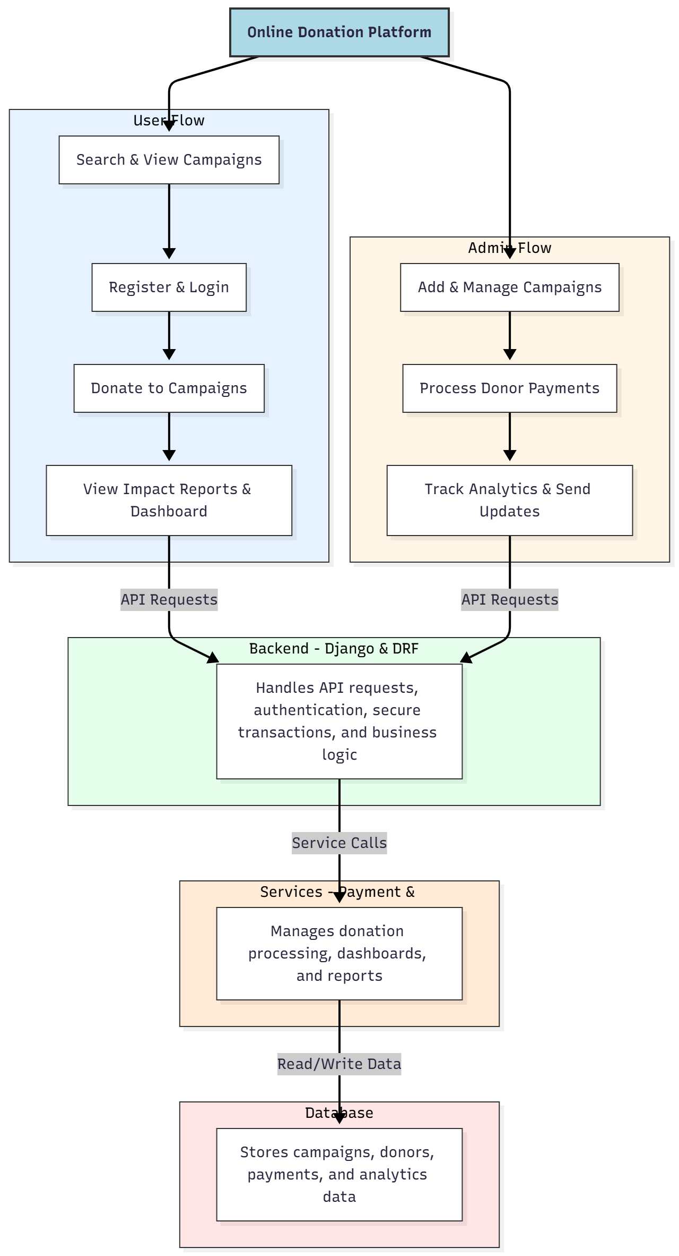

WORKING OF THE PROJECT:
Users browse campaigns, register on the platform, and donate securely to selected campaigns. Donations are processed through backend services, which manage payments, store data, and update dashboards. Users can view personalized impact reports and contribution analytics. Administrators can add and manage campaigns, process donor payments, and monitor campaign performance through analytics dashboards. The system provides secure, real-time tracking of donations, ensuring transparency, accountability, and effective reporting for charitable organizations..

SOFTWARE REQUIREMENT:
- Backend:
  - Python 3.x
  - Django
  - Django REST Framework
  - SQLite/PostgreSQL
- Frontend:
  - Node.js and npm
  - React.js
  - Axios
- Development Tools:
  - Visual Studio Code
  - Postman (for testing APIs)
  - Git/GitHub (for version control)
- Server/Deployment (Optional):
  - Gunicorn, Nginx, or Heroku/AWS for hosting

ADVANTAGES OF THE PROJECT:

• Centralizes charitable campaign management
• Secure donor registration and payment processing
• Provides impact dashboards for transparency
• Enables administrators to manage campaigns efficiently
• Generates analytical reports for performance evaluation
• Web-based and accessible on multiple devices
• Enhances donor engagement and trust
• Facilitates data-driven decision-making for social causes

APPLICATIONS OF THE PROJECT:
• Charities and NGOs managing donation campaigns
• Social cause initiatives requiring donor management
• Fundraising platforms and crowdfunding campaigns
• Schools and colleges for donation drives
• Corporate CSR programs
• Community service organizations
• Transparent tracking of donor contributions
• Analytical dashboards for campaign performance

REFERENCES:

- Django REST Framework Documentation — Django Software Foundation. Django Documentation. Available: https://docs.djangoproject.com/
- Django REST Framework. DRF Documentation. Available: https://www.django-rest-framework.org/
- React. React Official Documentation. Available: https://reactjs.org/docs/getting-started.html
- Redux. Redux Documentation. Available: https://redux.js.org/introduction/getting-started
- PostgreSQL Global Development Group. PostgreSQL Documentation. Available: https://www.postgresql.org/docs/
- MySQL. MySQL Reference Manual. Available: https://dev.mysql.com/doc/
- Git. Git Documentation. Available: https://git-scm.com/doc
- Node.js. Node.js Documentation. Available: https://nodejs.org/en/docs/
- Axios. Axios Documentation. Available: https://axios-http.com/docs/intro
- Socket.io Documentation – https://socket.io/docs/

